35.59: a) Adding glass over the top slit increases the effective path length from that slit to the screen. The interference pattern will therefore change, with the central maximum shifting downwards.
b) Normally the phase shift is 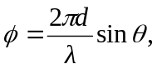 but now there is an added shift from the glass, so the total phase shift is now
So the intensity becomes 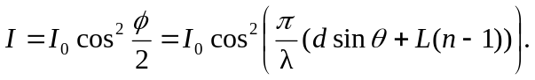
c) The maxima occur at 